* **Module-1**

Q1) What is SDLC

1. SDLC stands for system development life cycle.
2. It is a cyclic process to develop the

system for any organization. It consist the following steps to process:

(1) Primarily investigation

(2) System analysis

(3) System design

(4) Coding

(5) Testing

(6) Implementation

(7) Maintenance

Q2) What is software Testing

1. Software testing is the process of evaluating and verifying that a software product or application does what it is supposed to do.

Q3) Write SDLC Phases With Basic introduction

* SDLC stands for system development life cycle.
* It is a cyclic process to develop the

system for any organization. It consist the following steps to process

1. **Preliminary investigation** - During this phase, all the relevant information is collected from the customer to develop a product as per their expectation. Any ambiguities must be resolved in this phase only.
2. **System Analysis** - Once the requirement gathering is done, an analysis is done to check the feasibility of the development of a product. In case of any ambiguity, a call is set up for further discussion.
3. **System Design -** In this third phase, the system and software design documents are prepared as per the requirement specification document. This helps define overall system architecture.This design phase serves as input for the next phase of the model.
4. **Coding -** Once the system design phase is over, the next phase is coding. In this phase, developers start to build the entire system by writing code using the chosen programming language.
5. **Testing -** Once the software is complete, and it is deployed in the testing environment. The testing team starts testing the functionality of the entire system. This is done to verify that the entire application works according to the customer requirement.
6. **Implementation -** Once the software testing phase is over and no bugs or errors left in the system then the final deployment process starts. Based on the feedback given by the project manager, the final software is released and checked for deployment issues if any.
7. **Maintenance -** Once the system is deployed, and customers start using the developed system, following 3 activities occur

**Bug fixing** - bugs are reported because of some scenarios which are not tested at all

**Upgrade** – Upgrading the application to the newer versions of the Software

**Enhancement** – Adding some new features into the existing software

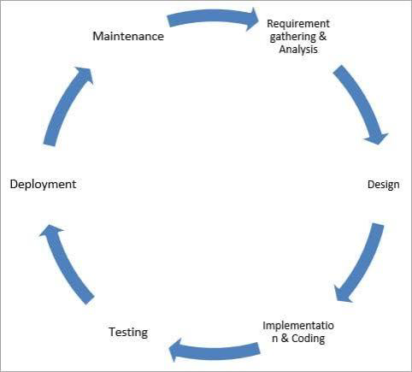

**Q4)** Explain Phases of Waterfall Model

| **Different phases** | **Activities performed in each stage** |
| --- | --- |
| **Requirement Gathering stage** | * During this phase, detailed requirements of the software system to be developed are gathered from client |
| **Design Stage** | * Plan the programming language, for Example Java,PHP.net * or databases like Oracle, MySQL, etc. * Or other high-level technical details of the project |
| **Built Stage** | * After design stage, it is built stage, that is nothing but coding the software |
| **Test Stage** | * In this phase, you test the software to verify that it is built as per the specifications given by the client. |
| **Deployment stage** | * Deploy the application in the respective environment |
| **Maintenance stage** | * Once your system is ready to use, you may later require change the code as per customer request |

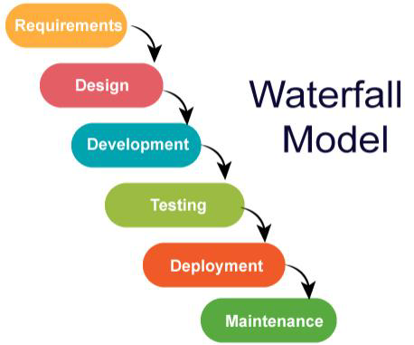

Q5) Write Phrases of spiral model

* Planning
* Design
* Construct
* Evaluation

Q6) What is agile methodology

* Agile SDLC model is a combination of iterative and incremental process models with
* focus on process adaptability and customer satisfaction by rapid delivery of working
* software product.
* Agile Methods break the product into small incremental builds.
* These builds are provided in iterations.
* Each iteration typically lasts from about one to three weeks.

Q7) What is SRS

* A software requirements specification (SRS) is a complete description of the behavior of the system to be developed.
* It includes a set of use cases that describe all of the interactions that the users will have with the software.
* Use cases are also known as functional requirements. In addition to use cases, the SRS also contains nonfunctional (or supplementary) requirements.

Q8 ) What is oops

* Object-oriented programming (OOP) is a programming language based on the concept of "objects", which can contain data and code.
* The data is in the form of fields (often known as attributes or properties), and the code is in the form of procedures (often known as methods).

Q9) Write Basic concepts of oops

* Objects
* Class
* Data Abstraction
* Data Encapsulation
* Polymorphism
* Data binding
* Inheritance

Q10) What is object

* Object is a real world entity such as a pen, laptop, mobile, bed, keyboard, mouse, chair etc.

Q11) What is Class

* A class is a group of objects that share common properties and behavior.
* **For example**, we can consider a car as a class that has characteristics like steering wheels, seats, brakes, etc. And its behavior is mobility.

Q12) What is encapsulation

* Encapsulation is defined as the wrapping up of data under a single unit. It is the mechanism that binds together code and the data it manipulates.

Q13) What is inheritance

* When a class derives from another class. The child class will inherit all the public and protected properties and methods from the parent class.

Q14) What is polymorphism

* Polymorphism is one of the OOPs features that allows us to perform a single action in different ways.

Q15) write agile manifesto principles

* **Individuals and interactions** - in agile development,self-organization and motivation are important, as are interactions like co-location and pair programming.
* **Working software** - Demo working software is considered the best means of communication with the customer to understand their requirement, instead of just depending on documentation.
* **Customer collaboration** - As the requirements cannot be gathered completely in the beginning of the project due to various factors, continuous customer interaction is very important to get proper product requirements.
* **Responding to change** - agile development is focused on quick responses to change and continuous development.

Q16)Explain Working methodology of agile model and write pros and cons.

* Agile SDLC model is a combination of iterative and incremental process models with focus on process adaptability and customer satisfaction by rapid delivery of working software products.
* Agile Methods break the product into small incremental builds.
* These builds are provided in iterations.
* Each iteration typically lasts from about one to three weeks.
* Every iteration involves cross functional teams working simultaneously on various areas like planning, requirements analysis, design, coding, unit testing, and acceptance testing.
* At the end of the iteration a working product is displayed to the customer and important stakeholders.

**Pros**

* Good model for environments that change steadily.
* Minimal rules, documentation easily employed.
* Enables concurrent development and delivery within an overall planned context.
* Little or no planning required.
* Easy to manage
* Gives flexibility to developers

**Cons**

* Not suitable for handling complex dependencies.
* More risk of sustainability, maintainability and extensibility.
* An overall plan, an agile leader and agile PM practice is a must without which it will not work.
* Strict delivery management dictates the scope, functionality to be delivered, and adjustments to meet the deadlines.
* Depends heavily on customer interaction, so if the customer is not clear, the team can be driven in the wrong direction.
* There is very high individual dependency, since there is minimum documentation generated**.**

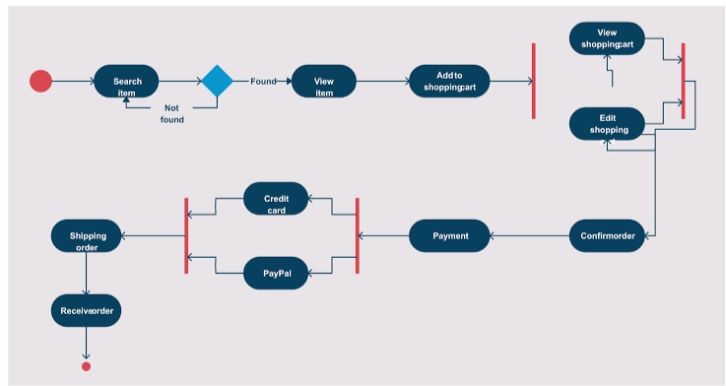Q17) Draw use case diagram for online shopping using Payment gateway

Q18) Draw use case diagram of online shopping using COD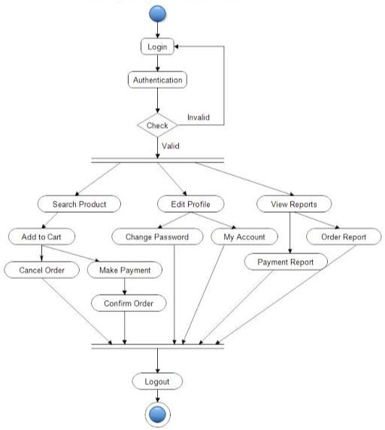

Q19) Draw use case diagram for online book shopping

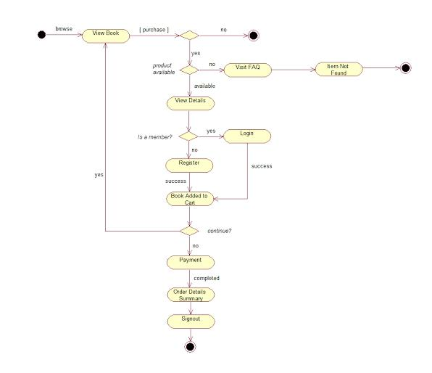

Q20) Draw use case diagram of online payment system

